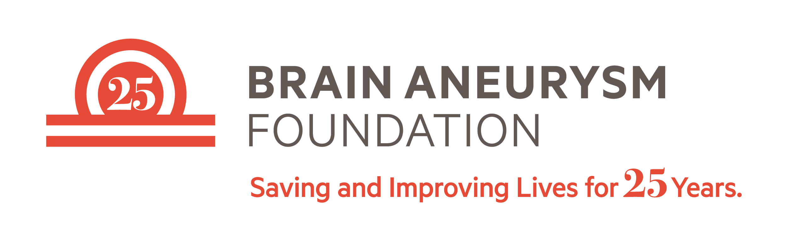

Dear [healthcare staffer first name],

Hope this finds you well. As a constituent of [Representative/Senator last name] and resident of [city], I am reaching out to express my support of “Ellie’s Law” and urge you to cosponsor this bill that would increase federal funding for brain aneurysm research.

This legislation is important to me because [describe your personal connection].

Brain aneurysms are one of the most underfunded disease research projects in the U.S. in terms of the number of Americans affected and the tremendous loss of life, diminution of quality of life for survivors, and the long-term medical costs for families affected. Ellie’s Law is a bipartisan bill introduced by Reps. Yvette Clarke (D-NY) and Peter King (R-NY) (H.R. 594) and Sen. Richard Blumenthal (D-CT) (S.864) and was drafted in consultation with members of the brain aneurysm medical and research communities. Ellie’s Law would provide the first ongoing dedicated research funding stream for breakthroughs in preventing potentially fatal brain aneurysms from rupturing and improving the long-term medical consequences and quality of life issues for aneurysm survivors. Now is the time to address this critical issue by adequately funding brain aneurysm research. This legislation will save lives, and I urge your support of Ellie’s Law and increased federal funding for brain aneurysm research.

For more information or to sign on as a cosponsor of H.R. 594/S. 864, please contact:
Kwamme Anderson (Rep. Clarke) Kwamme.Anderson@mail.house.gov, Deena Tauster (Rep. King) Deena.Tauster@mail.house.gov, or Brian Steele (Sen. Blumenthal) Brian_Steele@blumenthal.senate.gov

Attached are letters of support for Ellie’s Law from the American Association of Neurological Surgeons, as well as further background information about Ellie’s Law. Additional endorsements are listed below.

Please reach out if you have any questions or if I can be helpful.

Thank you,
[name and contact information]

Please open file
Ellie’s Law Endorsements:
- American Association of Neurological Surgeons/Congress of Neurological Surgeons
- Brain Aneurysm Foundation
- The Bee Foundation
- Rafael Tamargo, MD
Professor of Neurological Surgery
Professor of Otolaryngology-Head and Neck Surgery
Walter E. Dandy Professor of Neurosurgery
Director, Cerebrovascular Neurosurgery
Neurosurgical Co-Director, Neurosciences Critical Care Unit
Professor of Neurosurgery
Vice-Chairman, Department of Neurosurgery
The Johns Hopkins Hospital
- Paul Camarata, MD
Professor and Chairman Department of Neurosurgery
University of Kansas Medical Center
- Robert D. Brown Jr, MD, MPH
Chair, Division of Stroke and Cerebrovascular Disease
John T. and Lillian Mathews Professor of Neuroscience
Professor of Neurology, Mayo Clinic College of Medicine and Science
Department of Neurology
Mayo Clinic
- Sepi Amin-Hanjani, MD
Professor & Program Director
Co-Director, Neurovascular Surgery
Department of Neurosurgery
University of Illinois at Chicago
- Stanley J. Berman, PhD
Vice President for Academic Affairs and
Associate Professor
William James College in Newton, MA
- Ajith Thomas, MD
Co-Director Brain Aneurysm Institute
Program Director Cerebrovascular Fellowship
Beth Israel Deaconess Medical Center
Associate Professor
Harvard Medical School
- Christopher S. Ogilvy, M.D.
Director, Endovascular and Operative Neurovascular Surgery
BIDMC Brain Aneurysm Institute
Professor of Neurosurgery
Harvard Medical School

- Edward R. Smith M.D.
R. Michael Scott Chair in Neurosurgery
Co-Director, Cerebrovascular Surgery and Interventions Center
Director, Pediatric Cerebrovascular Surgery
Department of Neurosurgery / Vascular Biology Program
Children's Hospital Boston / Harvard Medical School
- Robert M. Friedlander, MD
Chairman Department of Neurological Surgery
Walter E. Dandy Professor of Neurosurgery and Neurobiology
University of Pittsburgh School of Medicine
University of Pittsburgh Medical Center
Co-Director UPMC Neurological Institute
UPMC Presbyterian Hospital
Department of Neurological Surgery
- Brian T. Jankowitz MD
Assistant Professor
Co-Director, Endovascular Therapy
Director, Neuroendovascular Fellowship Program
Department of Neurological Surgery
UPMC Presbyterian
- Eric Nussbaum, MD
Saint Joseph’s Hospital
National Brain Aneurysm & Tumor Center
Medical Director, Neurovascular Neurosurgery Program at United Hospital
Minnesota Neurovascular and Skull Base Surgery, PA
- Gary K. Steinberg, M.D., Ph.D.
Bernard and Ronni Lacroute-William Randolph Hearst Professor of Neurosurgery and the Neurosciences
Chair, Department of Neurosurgery
Stanford University School of Medicine
- L. Fernando Gonzalez, MD
Professor of Neurosurgery
Co-Director Cerebrovascular and Endovascular Neurosurgery
Duke University
- John A. Wilson, MD
Associate Professor, Neurosurgery
Radiology
Wake Forest Baptist Health
Winston-Salem, NC
- Adnan H. Siddiqui, MD, PhD
Associate Professor of Neurosurgery
Associate Professor of Radiology
Director of Neuroendovascular Research and Stroke Service
University at Buffalo Neurosurgery
State University of New York

